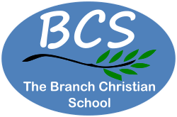
Job Advert

Job Title: SEND one to one support
(one year post 2026-2027)
For more information and/or an application pack email office@branchchristianschool.org.uk and put ‘BCS Post Advertised’ in the subject
Location: The Branch Christian School, Dewsbury
Job Type: One Year/Full time
Hours: 38 hrs / week
Salary: £26,000
Close date for applications: Friday 14th August 2026
Interviews to be held week beginning 17th August 2026
Starting Date: September 2026
This is a key position requiring some experience of SEND, a requirement to work within the ACE (Accelerated Christian Education) framework and a willingness to be flexible, working where directed by management, including within our Learning Centres and with small groups.
Safeguarding Statement:
Our organisation, The Branch Christian School, is committed to safeguarding and promoting the welfare of all children and young people. We believe that all our children deserve a safe happy and healthy life we expect all staff are committed to this.
The Branch Christian School has a full safeguarding Children policy which staff are familiarised with at the start of each school year.
At interview the candidate would be asked questions relating to Safeguarding.

