PERSON SPECIFICATION – One to One SEND Support | 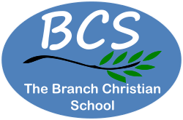
 | Essential | Desirable
Qualifications
ICCE Vocational Level or  4 GCSE’s including Maths and English at grade 4/C or relevant experience |  | ü
Willingness to participate in training and development opportunities |  | ü
Experience
Work with young people with SEND | ü
Knowledge and Skills
Confident with use of Microsoft Office 365 |  | ü
Ability to work in a way that promotes the safety and wellbeing of children and young people | ü
Knowledge of Safeguarding procedures |  | ü
Ability to work in partnership with all staff, teaching and support, governors, and parents. | ü
Behaviours, Attitudes & Values
Patience | ü
Self Control | ü
Friendly, approachable, and professional manner | ü
Total honesty, integrity, and reliability | ü
Willingness to learn | ü
Maintain good working relationships with colleagues | ü
Ability to consistently model the positive values, attitudes, and ethos of the school | ü
A commitment to own personal development |  | ü
Flexibility attitude to work |  | ü
Able to maintain confidentiality in all school matters | ü
Other
Eligible to live and work in the UK for Sept 2026 – July 2027 | ü
Suitability to work with children | ü

