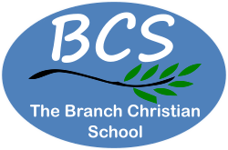

The Branch Christian School – Building Lives for the Future
The Branch Christian School Vision
Christ Centred
This comes first for us as we believe that Jesus Christ died, rose again, ascended into Heaven and as the rightful King of all Creation will one day return and we want everything we do to honour Him. Our intention is that each child would see themselves as unique in God’s eyes, accepted, valued and with a hope and future.
Train up a child in the way he should go, and when he is old he will not depart from it.
Proverbs 22:6 NKJV

Our Vision
We are committed to offer quality Christian based education in a safe nurturing environment, inspiring students to have a love and desire of lifelong learning, developing their character and becoming positive members of their community in the future.
At The Branch Christian School our aim is that students in our school:
- Become confident and enthusiastic learners who can work independently or as part of a team to achieve their potential in all aspects of school life and equip them beyond school life.
- Gain a good set of social and moral values; including being compassionate, tolerant, honest, and respectful; and the unselfishness to work for the good of others, as unto the Lord.
- Value themselves, each other, their community and society more widely.
- Cultivate self-control to order their own lives.
- Acquire the self-motivation and skills to develop their abilities and talents.
- Have a sense of pride in themselves and their achievements and a strong belief in their own uniqueness.
- Have happy memories of enjoyable, challenging and exciting learning and high aspirations for the future.
- Become ready for the next step in their education; thoroughly prepared for life and with a lasting
love of learning.
Our Aims
We aim to achieve our vision by:
- Providing a varied and balanced curriculum that will develop each child’s full potential and creativity.
- Providing equality of opportunity and equal access to the learning and social activities on offer.
- Providing a variety of approaches to learning that give children the skills to enable them to take a greater responsibility for their own learning.
- Providing a happy, safe and secure environment.
- Encouraging the necessary learning and social skills for taking a positive role in life.
- Valuing each child and their contributions.
- Fostering good character, a sense of responsibility, honesty and integrity.
- Developing self-respect, self-confidence and taking a responsibility for one’s own actions.
- Developing care and respect paying particular regard to the protected characteristics of the Equality Act 2010. As well as teaching this in specific subject areas such as PSHE, this will be embedded in the curriculum.
- Embedding the British values of democracy, the rule of law, individual liberty, and mutual respect and tolerance of those with different faiths and beliefs, into the curriculum as well as specific subjects such as PSHE.
- The use of an effective behaviour management policy ensuring that pupils’ behaviour is conducive to effective learning for ALL learners.
- Effective preparation of pupils for the opportunities, responsibilities and experiences of life in British society.
- Taking positive action against discrimination and stereotyping on the grounds of ability, social class or any of the protected characteristics of the Equality Act 2010.

Our Values
The Branch Christian School has the following values, which underpin all that we do:
- Parents have the primary responsibility before God for educating their children, working in partnership with church and school to prepare the children for adult life. We believe that the role of parents in the education of their children is very important and we seek to work together with good, open communication.
- Commitment to excellence in all aspects of school life: we aim to do the best we can, and we encourage children to give of their best in everything they do.
- The importance of each child developing spiritually, physically, intellectually, creatively, socially, behaviourally and emotionally.
- Clear and consistent discipline: we work to maintain fair discipline throughout the school with a clear code of conduct that all staff and parents uphold.
- Respect for authority and honour for all. We teach the students to respect authority as given by God to parents, teachers and others in the school, Church communities and those in positions of responsibility e.g. the police, government etc.
- A Biblical world view in all areas of school life. We aim to develop a Biblical approach in all aspects of the curriculum, administration and pastoral care.
Our Curriculum
The Branch Christian School uses a Godly Bible based curriculum that covers a broad range of subjects delivered by dedicated teachers, enabling all students according to their abilities to make good progress through continuous assessment. We challenge our students to achieve their potential and develop their individual character.
We believe children were created to be loved and trained up in families and believe the small nurturing nature of the school offers a distinctive sense of Christian family and community preparing students for their future.
Our intention is that each and every student would see themselves as unique, accepted, valued and with a hope and a future. In addition to fostering a love for learning and encouraging and challenging our students to be the best that they can, we encourage them to see that with God they can face any challenge and not be overwhelmed by it.
During the pre-school years, play based learning will be interspaced with the ACE workbooks, to ensure the EYFS Learning Goals are met. This is partly because young children learn best through playing, but children also learn in many different ways. Using the books allows for assessment and any misconceptions can be identified and remedied quickly.
Within the ACE programme, in each subject, work is planned sequentially with core knowledge and skills connecting across the subject areas; it is individualised, cumulative and achieves progression as the students master the subject matter. From Preschool, the reading program is essential to underpin all the learning; the system is designed to introduce our students to reading early and build strong readers. Whilst much of what they read facilitates their learning, we actively encourage wider reading to foster reading for pleasure which we believe will impact them across all areas of the curriculum and in their life outside education.
Our students are encouraged to work hard to overcome in areas where they are challenged, developing resilience and a sense of self-worth and a belief that they can do their work and take pride in their achievements. We place God at the centre of all that we do as we believe that when students are secure in His love and provision of redemption through the death and Resurrection of Jesus and His protection, alongside our belief in them, they will thrive and have a sense of wellbeing, positioning them to develop their academic ability alongside their wider talents and skills.
We offer a wide variety of subjects in the afternoons especially designed to complement the PACE material, building team skills, group work, investigations and bringing a dynamic, practical level to the more theoretical PACE work. The synergy between the Complementary Activities and the PACE work gives a holistic, well rounded curriculum ensuring work is relevant and prepares our students for life in modern Britain and beyond. Through this approach, we aim to support their development as independent citizens who are able to contribute to the society they live in, having had the opportunity to develop critical thinking skills.
We foster in students the belief that whilst it is important that they work hard to achieve all that they can whilst at school, they are not the sum of their academic achievements, but have implicit worth in God’s eyes and in ours; we nurture them to see their value as a human being and to value others.

Our curriculum is designed with the following principles implicit across all subjects:
- Students should have a basis for developing and maintaining proper relationships with God, themselves and others.
- Students should have an ability to think about the ultimate purpose of life.
- Students should be equipped in a changing world.
- Students should be able to argue rationally and make reasoned judgements.
- Students should develop enquiring minds, be able to learn for themselves, set short- and long-term goals and appreciate the importance of completing tasks.
- Students should appreciate diversity.
- Students should know the 9 protected characteristics of the 2010 Equality Act and show an appropriate sensitivity toward them.
- Students should have a working knowledge of the British Values.
- Students should appreciate the need to listen to others and to think from another person’s point of view.
- Students should learn to become independent and possess the capability to work in co-operation with others.
- Students should be able to develop an intelligent interest in the social, political and natural world starting with a Biblical Worldview.
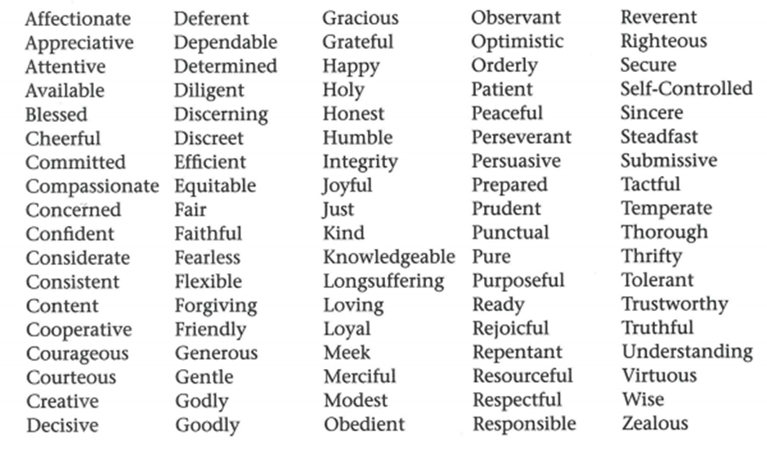
- Students should develop the 90-character traits of Jesus listed below:

Working at BCS
Staff whether paid or voluntary, work together well as a team at The Branch Christian School. Since the school started in 1994, we have had staff who have shown a long-term commitment as they shared the vision and values of the school. Our staff consider it a calling and a privilege to work in the school. Because of the size of the school, staff usually have a variety of roles which is generally fulfilling; the work provides areas for professional and personal development which we will support as we are able.

